Real-Time Applications Integrated Software Environment
2.0 What is RAISE?
Traditionally telecommunication service providers have installed independent hardware equipments at different locations for delivering telecom services. For example hardware equipment like Electronic switches which are installed at first floor of a building are dependent on other equipments like OFC transmission system installed at ground floor of the same building etc., for providing services. Innovation in digital communication technologies and convergence of information made humans to depend on telecommunication services for their daily activities. To provide interrupt-free service individual telecom equipment operational parameters has to be monitored regularly and separately, failure of which causes a denial of service to its customers and also revenue loss to the service provider. In the event of failure all this alarms’ are to be aggregated at a central place to trace out the original fault. This not only increases the restoration time but also reduces service provider revenue.
A further challenge to overcome and ensure good quality of service to the customer’s a low-cost reliable and redundant software environment named RAISE (Real-time Application Integrated Software Environment) was developed to monitor all the alarms in online with individual equipments centrally. The environment is integrated with redundant mobile technology to forward all monitored alarms immediately to the concerned supervisors. The environment is also integrated with a database to map and store retrieved information for analyzing and reporting. The environment integrated with a web server for reporting statistics and to have ease of access with the software.
This article titled “RAISE operational performance” starts with brief explanation of RAISE features, architecture, requirements and its installation procedure for implementation on Digital electronic exchanges.
2.1 RAISE features
- A common environment for all applications
- Online monitoring system for all applications
- Integrated database
- Supports different external database servers like Oracle, SQL Server, MY SQL etc
- Integrated mobile technology
- Redundant Mobile technology using primary and secondary resources
- Single place of execution for all applications and locations
- Works in both stand-alone and stand-in modes
- Runs on any operating system that supports .NET runtime
- Integrated web server
- Complete GUI interface for ease of access.
- Report server for dashboard and statistics
- Independent of CDR and DOTSOFT
- No need of installing new hardware resources
- Uses less computer resources.
- Uses existing BSNL network resources.
3.0 RAISE architecture
Raise is an online telecom monitoring environment integrating different applications running on different systems by aggregating them at a central place. RAISE is a six tier architecture consisting of Application, RAISE Aggregator, LAN, RAISE software, RAISE Database and Mobile environment.
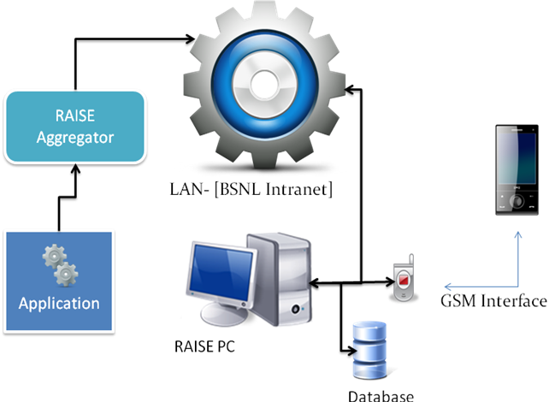
Fig-1 RAISE Architecture

3.1. Application
3.1.1. What is an ‘Application’?
The application is the telecom equipment monitoring system. The application can be software or a hardware which is used by the telecom equipment to monitor its status and performance. For example the alarms from electronic exchanges like CDOT, OCB, EWSD, etc., are considered as Exchange monitoring application. The application is connected with suitable hardware to the RAISE Aggregator.
3.1.2 Applications integrated.
RAISE integrates different types of applications that are essential and plays a vital role in both performance and revenue of telecom service providers. Different applications integrated by RAISE are
- Exchange monitoring
- OFC ring monitoring
- Power alarms
- Fire alarms
- DSLAM alarms
- Leased line failure alarms
3.2. RAISE Aggregator
RAISE aggregator can be a software or hardware that provides a means of communication for RAISE software to interact with the telecom equipment. RAISE aggregator connects different telecom equipments with suitable hardware or software and converts them into a RAISE standard interface i.e. Ethernet. The RAISE aggregators are connected to a Local Area Network.
3.3. LAN (Local area Network)
RAISE uses a standard interface, Ethernet to interact with each application using aggregator. The intranet network of BSNL is used to connect all aggregators and is carried forward to a central place.
3.4. RAISE PC
RAISE PC is the computer in which RAISE software is installed. It is the heart of the Real-time Applications Integrated Software Environment. It communicates with each element of the environment like RAISE aggregator, mobile environment, database, etc., and assigns the information to be processed. The RAISE software is developed using .NET frame work. RAISE is integrated with mobile environment and a database. RAISE also supports external database servers like Oracle, SQL Server, MY SQL, etc. It has an internal web server to communicate with the external world. The software provides ease of access with the environment using GUI.
RAISE initiates the process of telecom equipment monitoring. The applications or telecom equipments are monitored on-line by the RAISE software. RAISE periodically interacts with the applications or telecom equipments and retrieves monitoring information from the application or equipment. This then mapped to corresponding module or element of the application with the database. Depending upon the threshold or operational parameters defined, the RAISE initiates a fault-id of the element and commands the mobile environment to send a fault SMS to the corresponding supervisors. On restoration of the fault observed the RAISE closes the fault-id and commands the mobile environment to send a restoration SMS to the corresponding supervisors. Not only this, the RASIE sends every day at defined hour a remainder SMS of active faults of each equipment or application in consolidated form.
The RAISE is integrated with a report server which generates reports on the processed information. The report server has a pre-defined report formats to provide information for statistics and analysis as required by the administration.
The following specifications are required to install RAISE software in the PC
- Any operating system that supports .NET run time (recommended : Win-XP or greater windows versions)
- .NET 3.5 sp1 or higher runtime installed (free download from Microsoft)
- Minimum of 512MB RAM (recommended 1GB RAM)
- Ethernet card [NIC] connected to a LAN network which can access RAISE aggregators
- USB interface for mobile environment communication
3.5 Database.
RAISE is integrated with an internal database to store the information that is retrieved from the application or equipment. The database maintains the mapping of each element or module of telecom equipment to the corresponding supervisor’s mobile numbers. The database also contains the RAISE software running parameters and its associated information. It also supports external database servers like Oracle, SQL server etc., if required.
3.6 Mobile environment
Mobile environment is used to send the alarms as SMS to the supervisors using GSM interface. The mobile environment sends the SMS via any of the redundant sources. The redundant sources are
- Any GSM mobile with GPRS capability that can be connected to a PC via data-cable.
- The UDAAN SMS server.
The messaging system is a hierarchical-level based messaging. I.e. in the event of failure, first the SMS is send to Level-1 (JTO,SDE,DE,..) officers and after a pre-defined interval if the failure is still active then the SMS is forwarded to level-2(DGM,GM,..) officers as mapped in the database. The same is repeated in the event of restoration. The environment can map any element of equipment to any number of mobile numbers.

4.1 RAISE hardware setup for Exchange Alarms
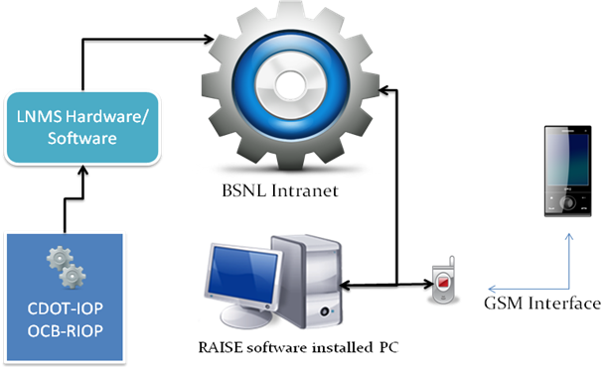
Fig. 2 RAISE setup for Exchange alarms
4. Requirements for installing RAISE for Exchange alarms monitoring
- A dedicated exchange connectivity port from CDOT / OCB / EWSD
- RAISE aggregator : any of the below
LNMS router (Perle- jet stream 8500 – already installed by BSNL)
--or—
A spare COM-port in a PC at each main exchange as we do for hyper-terminal.
- Local area network for interconnection.
- A PC as specified in (3.4) at central location to install RAISE software
- A mobile with valid SIM card to send SMS
5.0 Installing RAISE for monitoring Exchanges
RAISE for exchange alarms can be installed in 6 easy steps. Each step is explained in detail at below.
5.1 Configuring Exchange’s for RAISE installation (Step-1)
- Find a spare IOP-port from CDOT or CV port from OCB and test its working
- Configure Exchanges from console are TTY as below
For CDOT-exchanges.
- create a username ‘analm’ with password as ‘analm’
- block the user from not entering into ‘IOP5C’ or ‘IOP5D’ prompt i.e. the user must get CRP after giving username and password
- allow the following commands for the above user to execute and verify its execution
  - displ-arm-list
  - displ-ls-sts
- verify this from a local hyper-terminal
For OCB Exchanges
- create a user with password as ‘COM[ctrl+F]TEL’
- configure the CV port with 9600-7-even-1-xon/xoff
- allow the following commands to be executed
- abfase
- fsmin
- cchil
- verify the execution
For EWSD Exchanges
- Connect the OMT terminal to a Windows-XP PC comport
- Load BCT boot
- Open BMML window
- Configure the OMT so that alarms are displayed automatically

